**Let’s create a docker image by manually installing software’s in container**

* Lets install a nginx in some container and create a image out of it
* lets create a container in a interactive mode

docker container run -p 8082:80 -it ubuntu:22.04 /bin/bash

# apt update

# apt install nginx -y

# service nginx start

* Now lets create a docker image from running container
* In the docker host

docker commit <container-name/id>

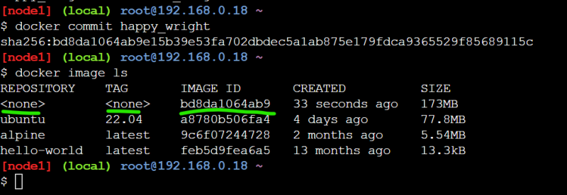  
* Now lets create an image and tag based the image id  
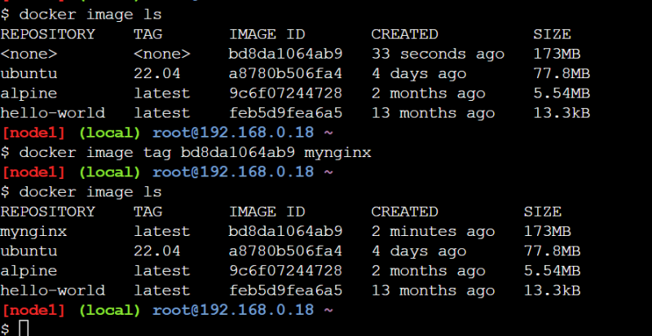

This approach creates images but no history of changes are available.